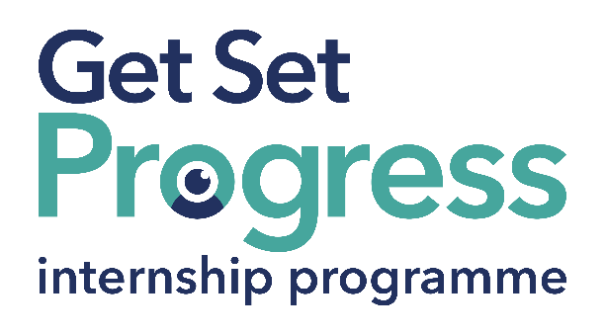


Assistive Technology Support Intern

Join us at Outlookers!
Thomas Pocklington Trust (TPT) and RNIB are collaborating with organisations from both the sight loss and wider charity sector as well as corporate organisations to create new opportunities for blind and partially sighted people to find employment through the Get Set Progress (GSP) Internship programme. Outlookers is delighted to be offering an internship as part of the Get Set Progress scheme.

About Outlookers
From our launch in 2008, when we were first known as Kirklees Visual Impairment Network, the organisation has grown from being a local sight loss network, to a thriving sight loss charity that we now know as Outlookers, which is our working name. The organisation has maintained a user-led approach that delivers a wide range of services which meet the practical, emotional, and social needs of local blind and visually impaired individuals, promoting independence through technology and peer support.
We are person-centred and focus on empowering people and removing barriers to independence, improved wellbeing, and enhanced quality of life through technology and peer interventions. We mostly support adults of all ages and backgrounds, and pride ourselves on providing accessible, compassionate, and impactful services. Join us and help people affected by sight loss get the right support, at the right time, in the right place.

Job Description
Role: Assistive Technology Support Intern
Department: Organisation-wide
Reporting to: Paul Hinchliffe, Technologies Support Officer
Location: Huddersfield and Batley offices, Hybrid, and in community venues.
Salary: Based on the Living Wage Foundation rate £13.45 per hour, £24,479 per annum (actual for a 35-hour week).
Contract type: Fixed Term nine months, full time 35 hours per week.

Purpose of the role:
The Assistive Technology Support Intern will play a key role in supporting blind and visually impaired individuals across Kirklees, to gain greater independence, digital inclusion, and confidence using assistive technology, and mainstream technology creatively. This internship is part of our commitment to increasing lived experience employment and empowering visually impaired individuals to lead fulfilling and independent lives.

Main responsibilities:
- Provide one-to-one and group-based training and demonstration sessions on assistive technology tools found on accessible features on smartphones, tablets, and smart speakers. Additionally, the role will assist people with work-related solutions, such as screen readers (eg, JAWS, NVDA), magnification software (eg ZoomText).
- Assist service users and volunteers in setting up and optimising devices to suit individual needs and levels of vision.
- Support users in understanding and navigating websites, apps, and digital platforms using accessible tools.
- Document and log individual user progress, outcomes, and feedback for monitoring and evaluation purposes using our databases.
- Assist in raising awareness of assistive technology within our support groups, community events, and stakeholder sessions.
- Gather feedback from service users on the effectiveness of approaches to assistive technology support they provide, and recommend improvements.
- Attend and actively participate in regular team meetings and supervision sessions.
- Actively engage in personal development activities, mentoring, and training opportunities provided through the Get Set Progress programme.
- Support colleagues and contribute to a collaborative working environment.
- Maintain professional boundaries and confidentiality when supporting individuals.

Person specification

Essential criteria
Important information:
- This role has a Genuine Occupational Requirement that the successful applicant be a person who is blind or partially sighted, in line with The Equality Act 2010.
- Interns need to be able to travel to the TPT Hub in London for development events throughout the course of the internship programme (costs covered by TPT).
- Having not previously undertaken the Get Set Progress internship programme.
- Successful applicants must have the Right to Work in the UK for the duration of the Internship. Sponsorship will not be provided.

Essential personal specifications
- Strong interest in assistive technology that supports independent living and choice-making for blind and partially sighted individuals.
- Familiar with commonly used technology such as smartphones, tablets, computers, smart speakers, and accessibility features (e.g. screen readers, magnifiers, voice assistants).
- Able to explain concepts clearly and sensitively to individuals with varying ranges of technical skills and confidence levels.
- Comfortable speaking to individuals one-to-one or in small groups.
- Works well collaboratively and is willing to support colleagues and volunteers across the organisation.
- Awareness of the importance of maintaining service user confidentiality, personal boundaries, and appropriate conduct in a support role.

Desirable personal specifications
- Experience of using braille and electronic braille devices
- Experience of using social media platforms including Facebook and TikTok

Closing date:
(14th of July 2026)

How to apply
If you are interested in applying for the above vacancy, please send your CV and a covering letter explaining why we should employ you as an intern to: admin@outlookers.org.uk. If you would like to arrange an informal chat about the role, please email paul.hinchliffe@outlookers.org.uk or call 07462 577870.

What are the benefits of a Get Set Progress internship for me?
As part of your 9-month internship, you will be part of a large cohort of fellow interns and gain the following:
- Obtain valuable work experience within the charity sector.
- Technology support (Including Microsoft Office) and upskilling opportunities.
- Online and in-person Training and development opportunities.
- Opportunity to present and network with Senior leaders within the Sight Loss Sector.
- Opportunities to build relationships with fellow interns.
- A personal mentor offering support, advice, and guidance throughout your internship.
- Help deliver positive changes for people with sight loss.


As part of the GSP Internship programme, you will also be enrolled on the TPT Works For Me Employment Programme, where you will gain bespoke employment support, guidance, and advice from the TPT Employment Team, some of the skills that you will receive support and guidance around include:
- CV writing.
- Job searching.
- Cover letter and speculative letter writing.
- Application form writing.
- Interview techniques.

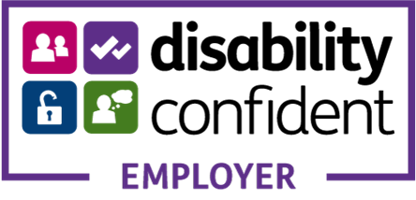

Thomas Pocklington Trust (TPT) is a charity established to provide services for visually impaired people: our mission is to improve the lives of people living with sight loss.
TPT is registered with the Disability Confident Scheme as a Disability Confident employer. Therefore, we believe in treating all employees fairly and we are committed to recruiting equally. TPT’s charitable objective and aim is to support visually impaired individuals back into work. For this reason, we are actively seeking applications from all backgrounds including disabled/visually impaired individuals and people who have lived experience of sight loss. We also guarantee all disabled applicants that reach the minimum appointment criteria an interview. We are happy to accept applications from all suitably qualified people who have the appropriate skills and talent regardless of their age, gender, race, religion, disability, sexual orientation or marital status.

End of Document

